**SAP UI5 Activity Day 08**

**Theme Designer**

Page 1

Page 2

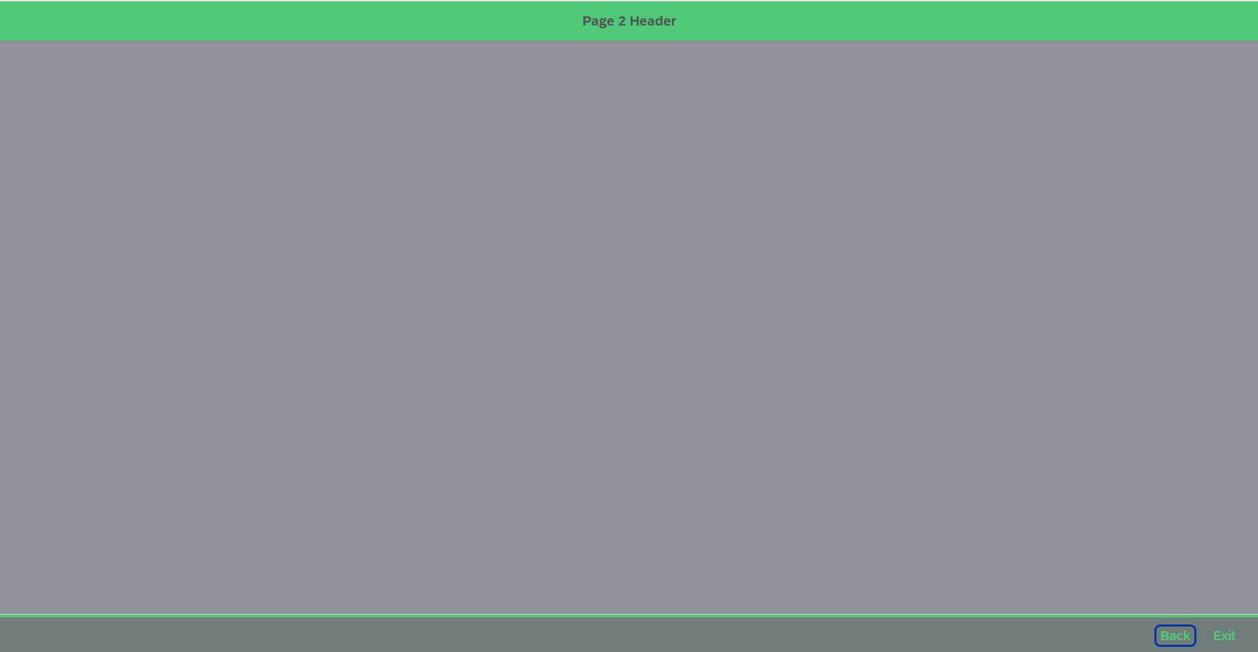

|  |  |
| --- | --- |
| Info Message   | Exit Message |